**TY B.Tech. (CSE) – II [ 2022-23 ]**

**5CS372 : Advanced Database System Lab. Assignment No. 3**

**PRN: 2020BTECS00023**

**Name: SUMIT NARAKE**

**Title: Design and implement a web enabled (portal) student MIS**

**(Management Information System) for University Schema**

**Technology Stack: ReactJS/ NodeJS/ MySQL GitHub Link of Screenshots:**

**MySQL WorkBench**

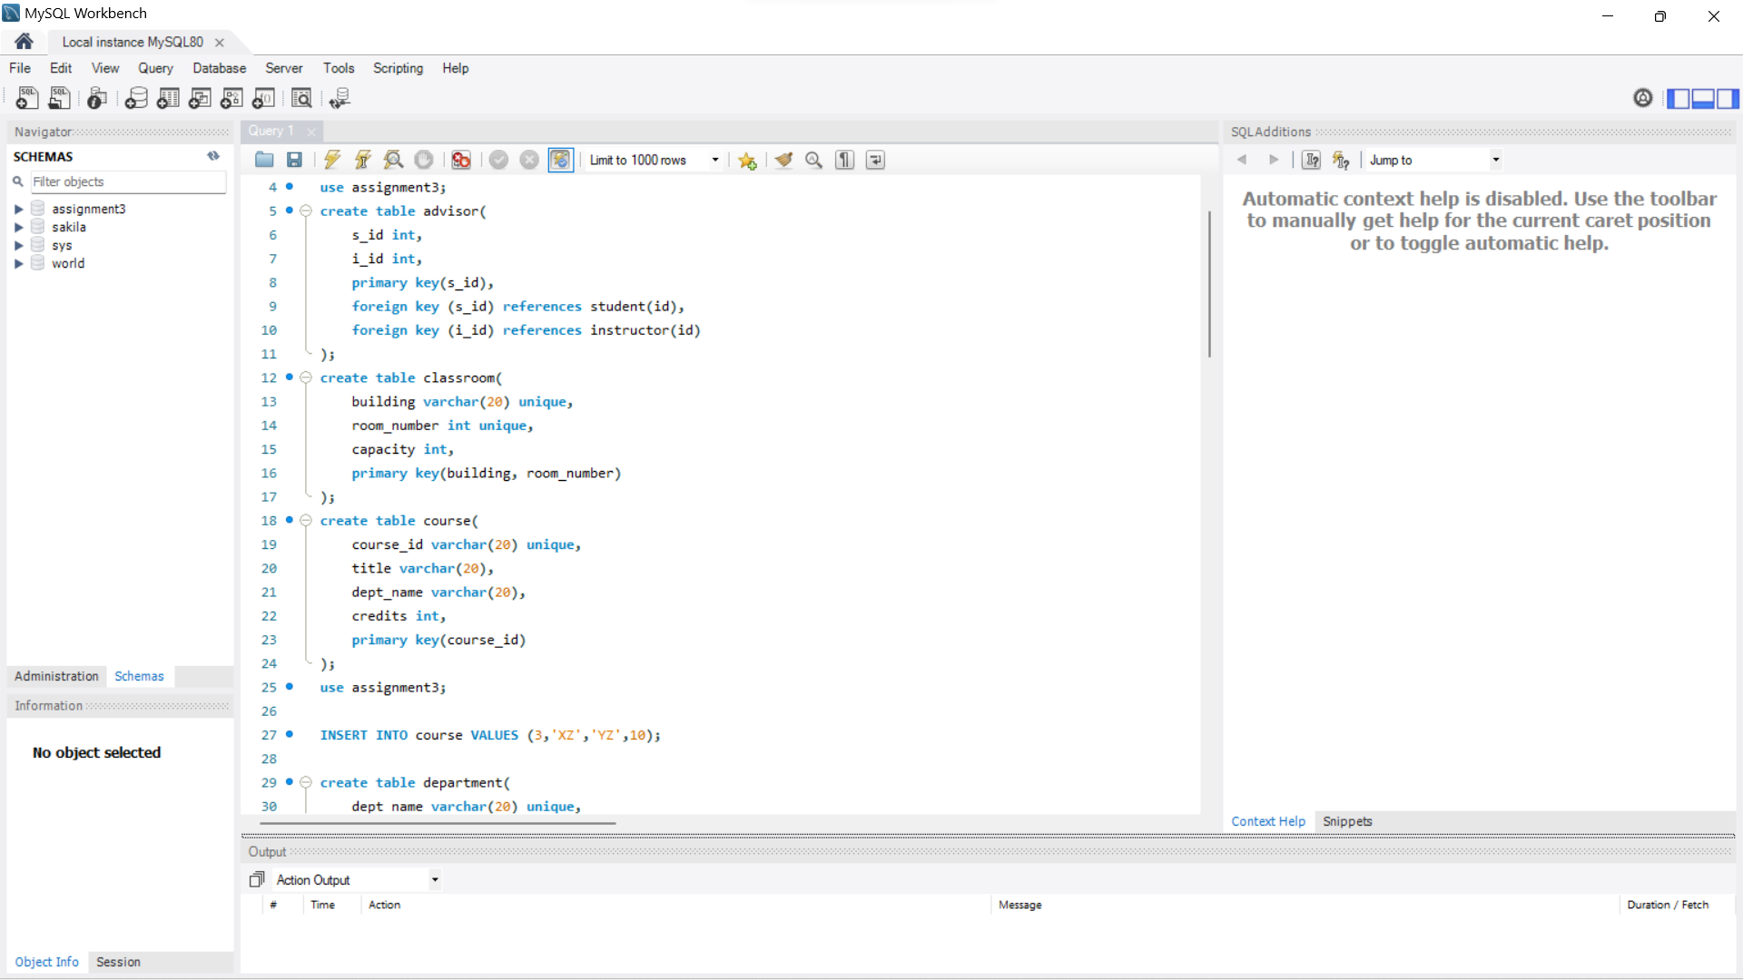

**UI:**

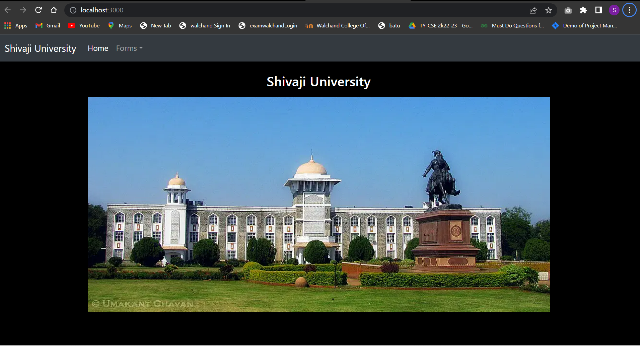

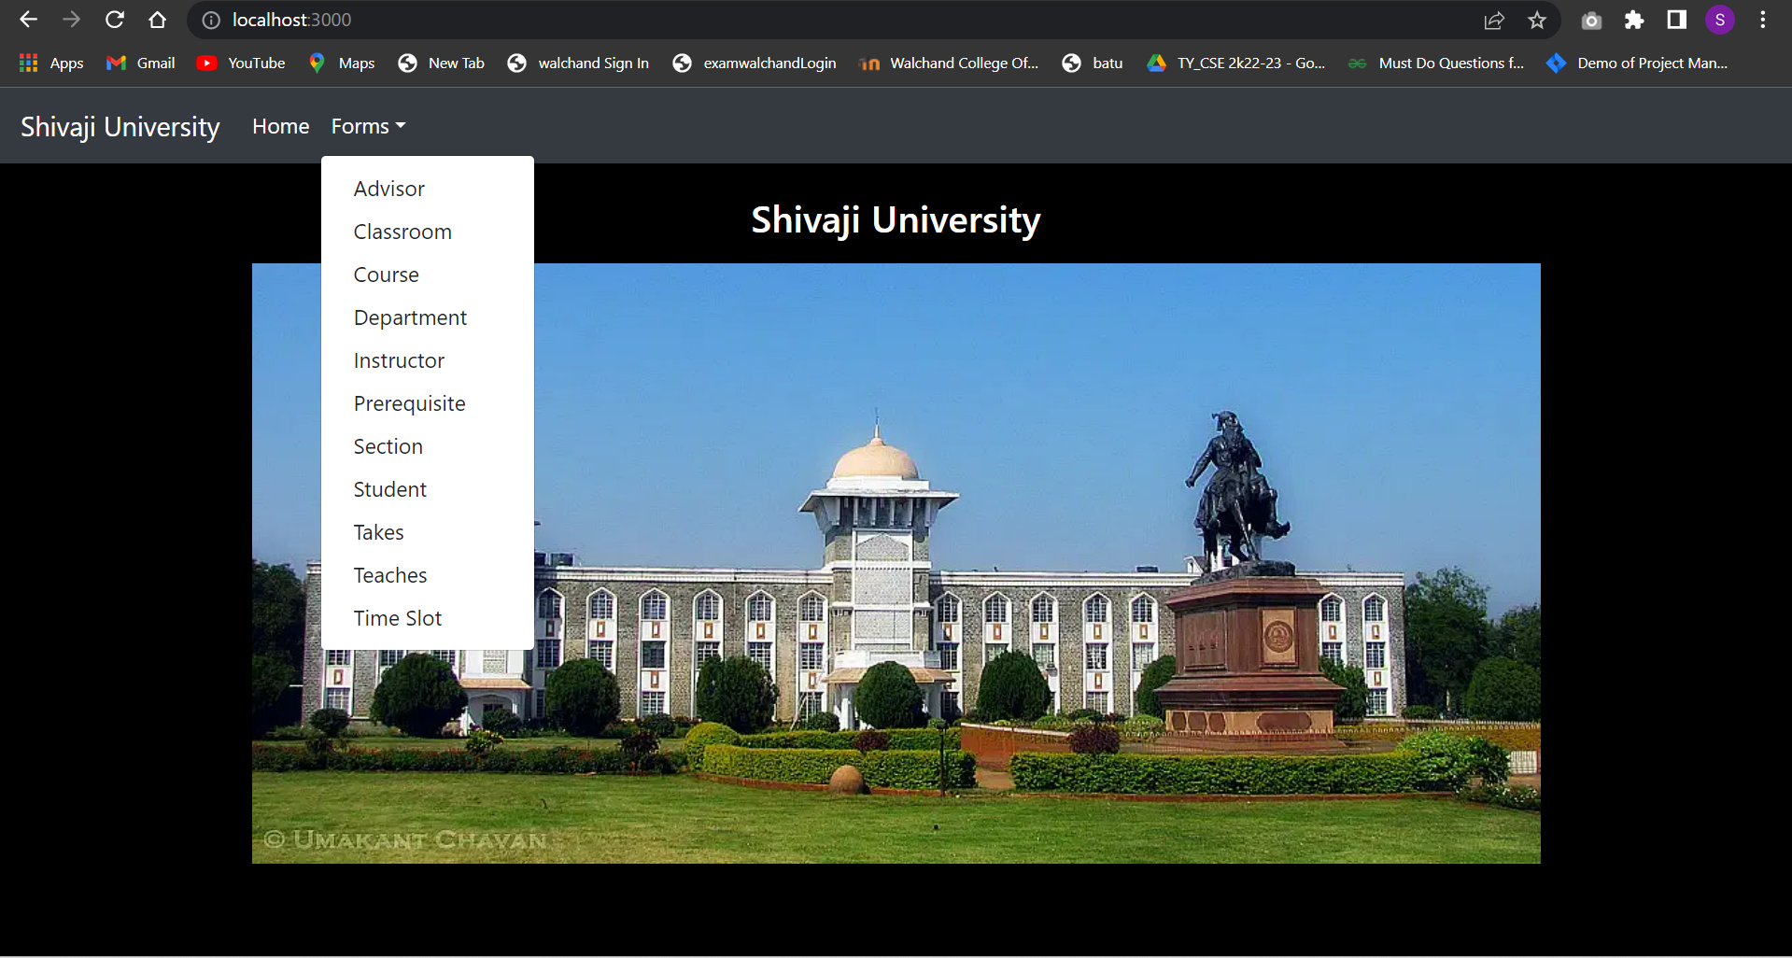

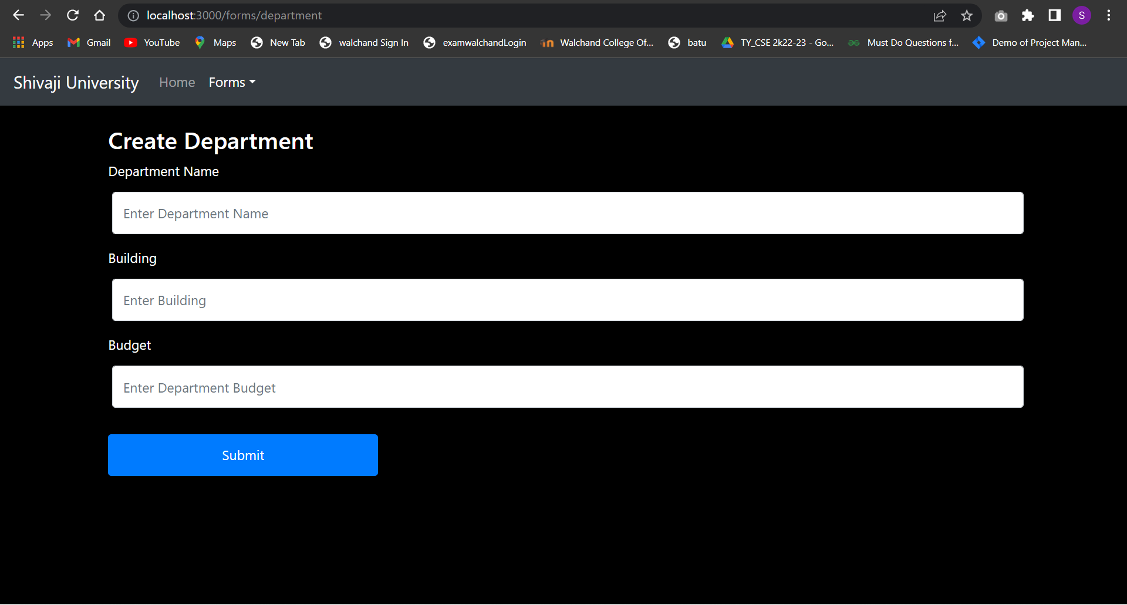

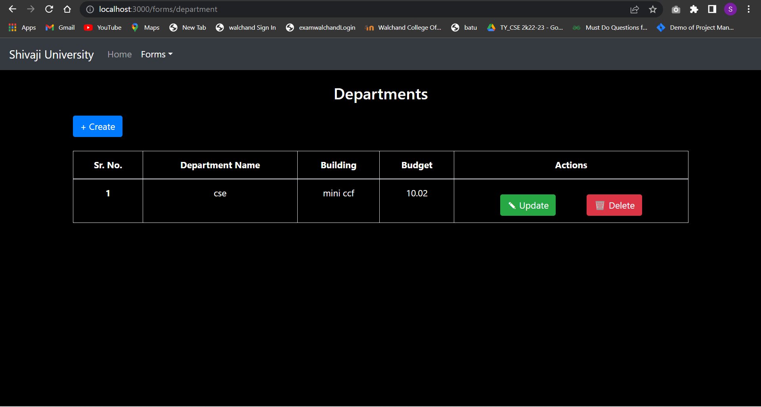

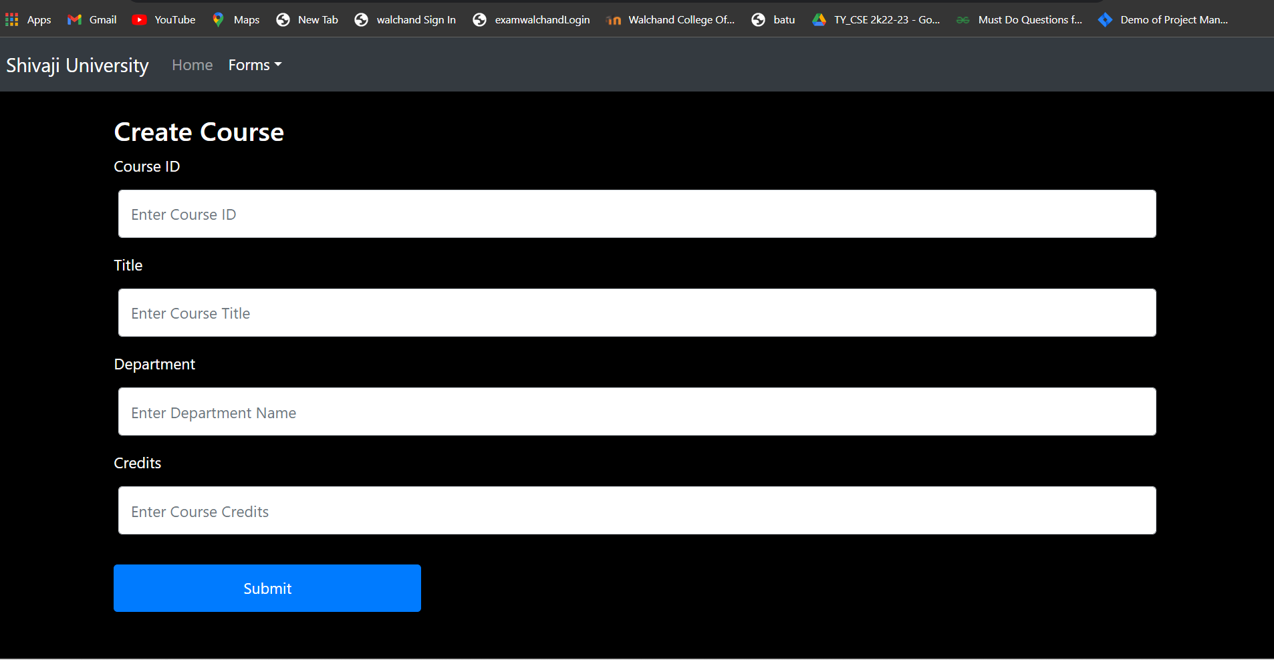

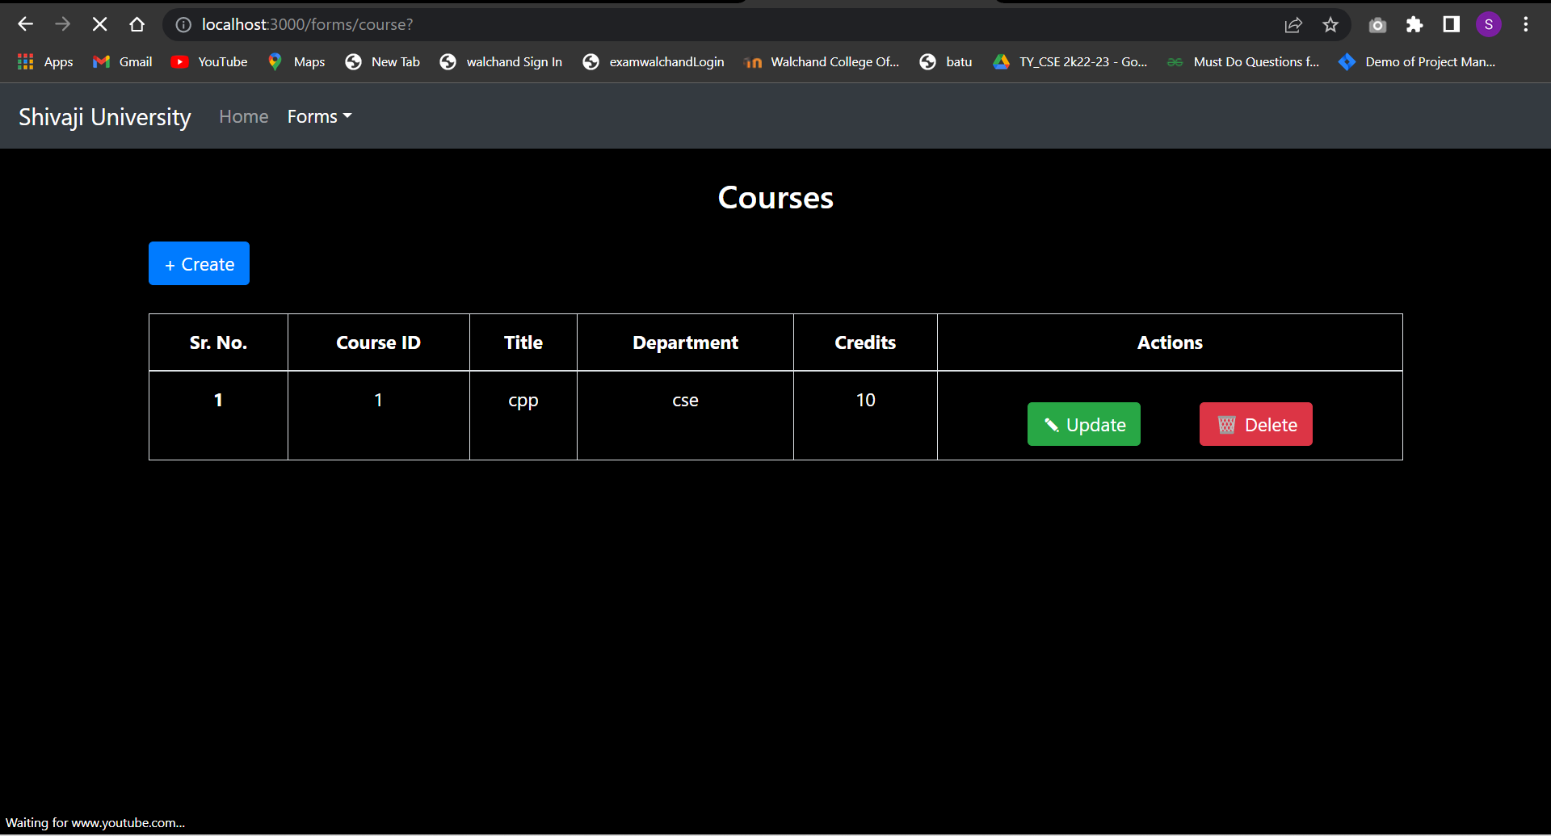

**Similarly, other features.**